***ORGINAL DESIGN***

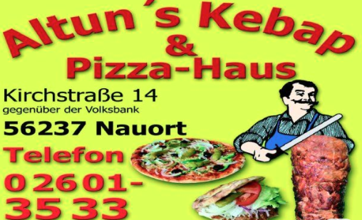

***MODIFIED DESIGN***

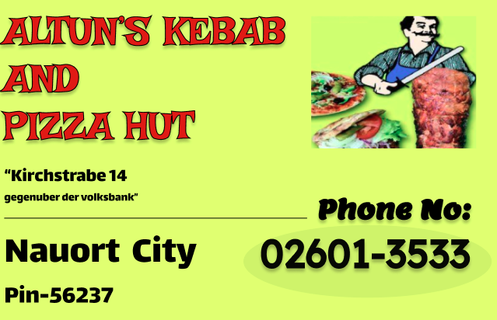

**1. Visual Hierarchy**

* **🔴 Bad:** No clear focus; competing elements, similar sizes/colors.
* **✅ Your Fix:** Bold headlines, contrasting CTA buttons, and intentional sizing (e.g., primary actions stand out).

**2. Layout & Spacing**

* **🔴 Bad:** Cluttered; cramped text, no breathing room.
* **✅ Your Fix:** Strategic whitespace, grouped related items, and balanced margins/padding.

**3. Alignment**

* **🔴 Bad:** Misaligned elements, chaotic grids.
* **✅ Your Fix:** Consistent left/center alignment and grid-based structure.

**4. Typography & Legibility**

* **🔴 Bad:** Hard-to-read fonts (e.g., script fonts for body text), low contrast.
* **✅ Your Fix:**
  + **Fonts:** Clean, scalable typefaces (e.g., Open Sans, Inter).
  + **Legibility:** Dark text on light BG (or vice versa), proper line spacing.

**5. Usability**

* **🔴 Bad:** Unclear navigation, hidden buttons, confusing icons.
* **✅ Your Fix:** Intuitive labels, recognizable patterns (e.g., shopping cart icon = cart).

**6. Consistency**

* **🔴 Bad:** Inconsistent buttons, colors, or styles.
* **✅ Your Fix:** Reusable components (e.g., same button style everywhere).

**7. Accessibility**

* **🔴 Bad:** Fails WCAG (e.g., light gray text on white).
* **✅ Your Fix:** High contrast, alt text for images, keyboard-friendly.